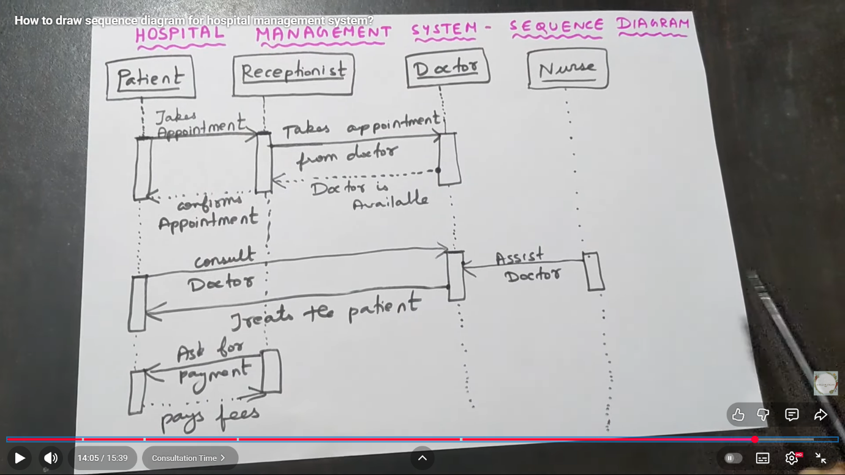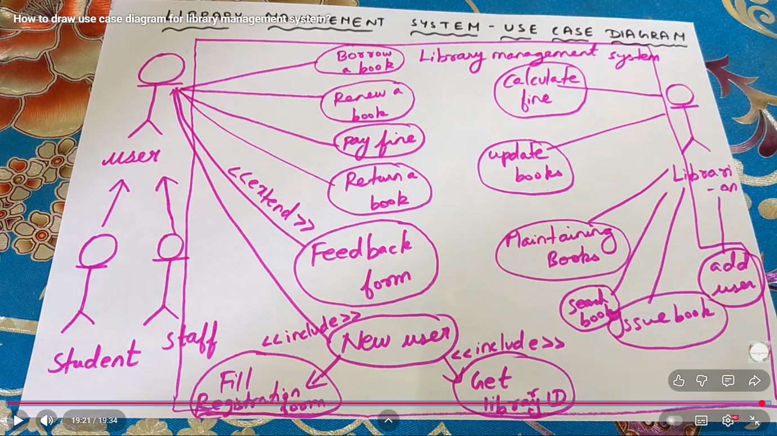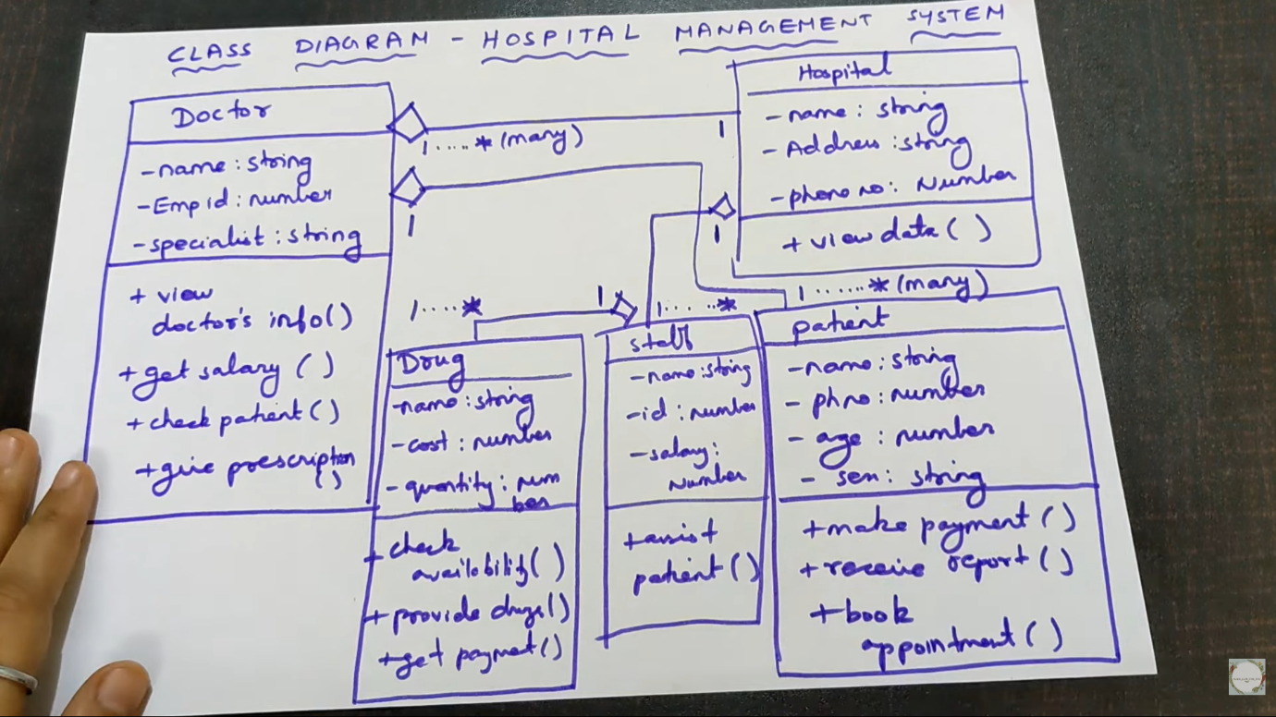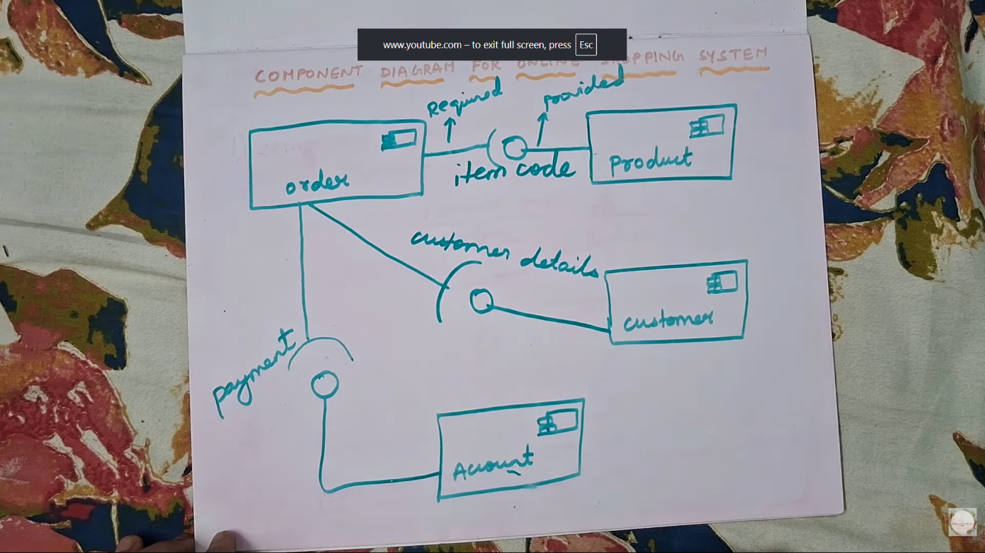

**✅ How to Write Functional Requirements**

Functional requirements describe **what the system must do** — its features, tasks, and behaviors.

Format structure:

FR-1: <Actor> shall be able to <action> so that <purpose>.

Example:

FR-1: The user shall be able to register with email and password.

FR-2: The system shall allow the librarian to add, update, and delete book records.

Functional requirements always describe **system actions**, not design or performance.

**✅ How to Write Non-Functional Requirements**

Non-functional requirements describe **quality attributes** of the system:

| **Category** | **Examples** |
| --- | --- |
| Performance | response time, processing speed |
| Security | login authentication, encryption |
| Usability | easy interface, accessibility |
| Reliability | uptime %, failure handling |
| Maintainability | updating, debugging |
| Portability | ability to run on multiple platforms |

Format:

NFR-1: The system shall respond to user requests within 3 seconds.

NFR-2: The system shall support up to 500 concurrent users.

**📌 Functional & Non-Functional Requirements Examples**

**1️⃣ Library Management System**

**Functional Requirements**

| **ID** | **Requirement** |
| --- | --- |
| FR-L1 | The system shall allow users to search books by title, author, or category. |
| FR-L2 | The librarian shall be able to add, update, and delete books. |
| FR-L3 | Users shall be able to borrow and return books. |
| FR-L4 | The system shall automatically calculate due dates and fines. |
| FR-L5 | The system shall allow admins to generate reports on issued and returned books. |

**Non-Functional Requirements**

| **ID** | **Requirement** |
| --- | --- |
| NFR-L1 | The system shall support up to 1000 users simultaneously. |
| NFR-L2 | Search results shall be displayed within 2 seconds. |
| NFR-L3 | System shall provide authentication for users and librarians. |
| NFR-L4 | Backup of data shall occur automatically once per day. |
| NFR-L5 | The system interface shall be user-friendly and simple to navigate. |

**2️⃣ Banking System**

**Functional Requirements**

| **ID** | **Requirement** |
| --- | --- |
| FR-B1 | Users shall be able to create bank accounts. |
| FR-B2 | Users shall be able to deposit and withdraw money. |
| FR-B3 | The system shall support online fund transfers between accounts. |
| FR-B4 | The system shall generate monthly account statements. |
| FR-B5 | The system shall send OTP for secure login and transactions. |

**Non-Functional Requirements**

| **ID** | **Requirement** |
| --- | --- |
| NFR-B1 | System shall ensure 24/7 availability with 99.9% uptime. |
| NFR-B2 | All transactions must complete in less than 5 seconds. |
| NFR-B3 | The system shall encrypt all sensitive data using AES-256. |
| NFR-B4 | The system shall support multi-factor authentication. |
| NFR-B5 | The system shall comply with banking standards such as PCI-DSS. |

**3️⃣ Hospital Management System**

**Functional Requirements**

| **ID** | **Requirement** |
| --- | --- |
| FR-H1 | The system shall allow patients to book appointments. |
| FR-H2 | Doctors shall be able to update patient medical records. |
| FR-H3 | The system shall store patient history and prescriptions. |
| FR-H4 | The system shall generate bills for patients based on treatments. |
| FR-H5 | The system shall allow admin to manage doctors, wards, and staff. |

**Non-Functional Requirements**

| **ID** | **Requirement** |
| --- | --- |
| NFR-H1 | The system must be accessible to authorized staff only. |
| NFR-H2 | Response time for loading patient data shall not exceed 3 seconds. |
| NFR-H3 | The system shall ensure data backup every 24 hours. |
| NFR-H4 | The system shall support role-based access control. |
| NFR-H5 | The interface shall support accessibility standards for healthcare staff. |

**4️⃣ Online Shopping System**

**Functional Requirements**

| **ID** | **Requirement** |
| --- | --- |
| FR-O1 | Users shall be able to create accounts and login. |
| FR-O2 | Users shall search, filter, and view products. |
| FR-O3 | Users shall add items to cart and place orders. |
| FR-O4 | The system shall support online payments (UPI, Card, COD). |
| FR-O5 | Admins shall manage products, categories, and inventory. |

**Non-Functional Requirements**

| **ID** | **Requirement** |
| --- | --- |
| NFR-O1 | The application must support up to 10,000 concurrent users. |
| NFR-O2 | Page load time shall not exceed 2 seconds. |
| NFR-O3 | System must support multiple devices (mobile, tablet, desktop). |
| NFR-O4 | The system shall ensure secure payment processing using SSL. |
| NFR-O5 | The system shall be available 24/7 except planned maintenance. |

**🎓 Tips to Identify Them During Exam:**

| **Question Type** | **It belongs to** |
| --- | --- |
| "What will the system do?" | Functional Requirement |
| "How well should it perform?" | Non-Functional Requirement |
| "Who can do what?" | Functional Requirement |
| "Speed, security, usability?" | Non-Functional Requirement |